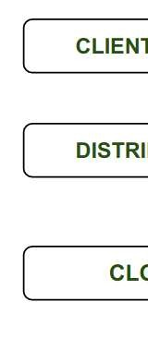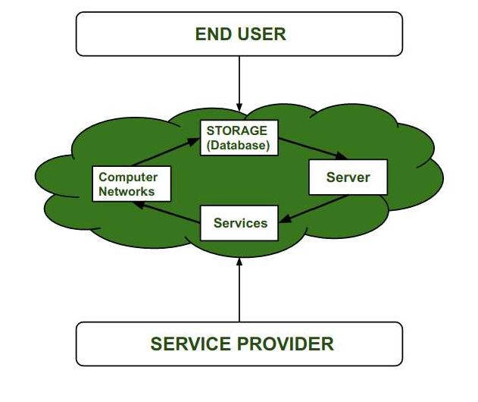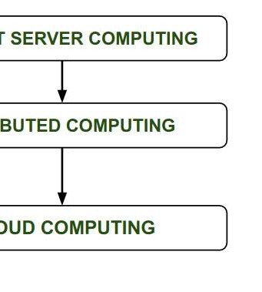

# DHANEKULA INSTITUTE OF ENGINEERING & TECHNOLOGY GANGURU::VIJAYAWADA

**UNIT-I**

Introduction of Cloud Computing: What is Cloud Computing, How it works, Types of Cloud, Goals & Challenges, Leveraging Cloud Computing, Cloud Economics and Total Cost of Ownership.

# Cloud Computing :

Cloud computing referred as the accessing and storing of data and provide services related to computing over the internet. It simply referred as it remote services on the internet manage and access data online rather than any local drives. The data can be anything like images, videos, audios, documents, files etc.

# Cloud Computing Service Provider’s :

Cloud computing is in huge demand so, big organization providing the service like Amazon AWS, Microsoft Azure, Google Cloud, Alibaba cloud etc. are some Cloud Computing service Provider.

# History of Cloud Computing:

Before Computing was come into existence, client Server Architecture was used where all the data and control of client resides in Server side.

If a single user want to access some data, firstly user need to connect to the server and after that user will get appropriate access.

But it has many disadvantages. So, After Client Server computing, Distributed Computing was come into existence, in this type of computing all computers are networked together with the help of this, user can share their resources when needed. It also has certain limitations. So in order to remove limitations faced in distributed system, cloud computing was emerged.

During 1961, John MacCharty delivered his speech at MIT that “Computing Can be sold as a Utility, like Water and Electricity.” According to John MacCharty it was a brilliant idea. But people at that time don’t want to adopt this technology. They thought the technology they are using efficient enough for them. So, this concept of computing was not appreciated much so and very less will research on it. But as the time fleet the technology caught the idea after few years

this idea is implemented. So, this is implemented by Salesforce.com in 1999.

This company started delivering an enterprise application over the internet and this way the boom of Cloud Computing

was started.

In 2002, Amazon started Amazon Web Services (AWS), Amazon will provide storage, computation over the internet. In 2006 Amazon will launch Elastic Compute Cloud Commercial Service which is open for Everybody to use.

After that in 2009, Google Play also started providing Cloud Computing Enterprise Application as other companies will see the emergence of cloud computing they also started providing their cloud services. Thus, in 2009, Microsoft launch Microsoft Azure and after that other companies like Alibaba, IBM, Oracle, HP also introduces their Cloud Services. In today the Cloud Computing become very popular and important skill.

# Advantages:It is easier to get backup in cloud.

It allows us easy and quick access stored information anywhere and anytime.

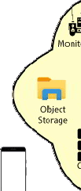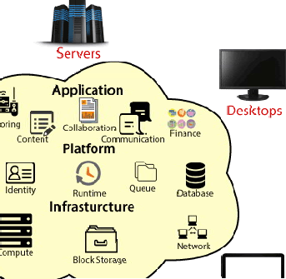

* It allows us to access data via mobile.
* It reduces both hardware ad Software cost, and it is easily maintainable.
* One of the biggest advantages of Cloud Computing is Database Security.

# Disadvantages:

* It requires good internet connection.
* User have limited control on the data.

**Introduction of Cloud Computing:**

* Cloud computing is the delivery of different services through the Internet, including data storage, servers, databases, networking, and software.
* Cloud storage has grown increasingly popular among individuals who need larger storage space and for businesses seeking an efficient off-site data back-up solution.
* Cloud computing is a virtualization-based technology that allows us to create, configure, and customize applications via an internet connection.
* The cloud technology includes a development platform, hard disk, software application, anddatabase.
* Cloud Computing provides an alternative to the on-premises data centre.
* With an on-premises data centre, we have to manage everything, such as purchasing and installing hardware, virtualization, installing the operating system, and any other required applications, setting up the network, configuring the firewall, and setting up storage for data.
* After doing all the set-up, we become responsible for maintaining it through its entire lifecycle.
* But if we choose Cloud Computing, a cloud vendor is responsible for the hardware purchase and maintenance. They also provide a wide variety of software and platform as a service. We can take any required services on rent. The cloud computing services will be charged based on usage.
* The cloud environment provides an easily accessible online portal that makes handy for the user to manage the compute, storage, network, and application resources. Some cloud service providers are in the following figure.

**What is Cloud Computing?**

The term cloud refers to a network or the internet. It is a technology that uses remote servers on the internet to store, manage, and access data online rather than local drives. The data can be anything such as files, images, documents, audio, video, and more.

There are the following operations that we can do using cloud computing:

* Developing new applications and services
* Storage, back up, and recovery of data
* Hosting blogs and websites
* Delivery of software on demand
* Analysis of data
* Streaming videos and audios

# Why Cloud Computing?

* Small as well as large IT companies, follow the traditional methods to provide the IT infrastructure. That means for any IT company, we need a Server Room that is the basic need of IT companies.
* In that server room, there should be a database server, mail server, networking, firewalls, routers, modem, switches, QPS (Query Per Second means how much queries or load will be handled by the server), configurable system, high net speed, and the maintenance engineers.
* To establish such IT infrastructure, we need to spend lots of money. To overcome all these problems andto reduce the IT infrastructure cost, Cloud Computing comes into existence.



**How Does Cloud Computing Work?**

* The cloud is basically a decentralized place to share information through satellite networks.
* Every cloud application has a host, and the hosting company is responsible for maintaining the massive data

centers that provide the security, information users send to the cloud.

storage capacity and computing power needed

to maintain all of the

* These hosting companies can sell the rights to use their clouds and store data on their networks, while also offering the end user an ecosystem that can communicate between devices and programs (for example, download a song on your laptop and it’s instantly synced to the music app on your iPhone).

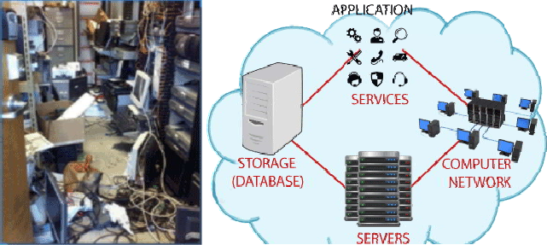

# Cloud computing applications

* Communication and collaboration
* Media streaming
* Big data analytics and insights
* Streamlining business processes
* Storage backups and data recovery

# Communication and collaboration

The entire Google suite of applications is cloud-based, from calendar to Google Chat. Additionally, so are popular apps like Zoom and WhatsApp, and all empower people to communicate and collaborate on a global scale.

# Entertainment

A combination of cloud computing and vastly improved internet speed has given rise to media streaminggiants like Netflix and Hulu, which host enormous databases of movies and TV shows available via the cloud. Cloud storage allows these companies and others like Spotify and Tidal, to exist.

# Big Data Analytics

Before the cloud, using big data to glean patterns and insights was a cumbersome and expensive process.The cloud has changed all that, eliminating the need for in-house development resources when compiling and analyzing data. Nowadays companies can collect data from a variety of sources, connect them to the cloud and dig for insights in real time.

# Business Processes

Without the cloud, innovative tools like Salesforce, Slack and myriad others designed to enhance and streamline the daily operations of companies would not exist.

# Storage Backups

Cloud computing is an important answer to the issue of data-loss and recovery on physical hard drives. Most

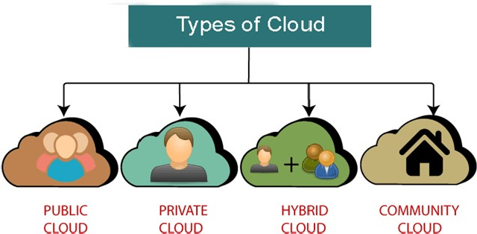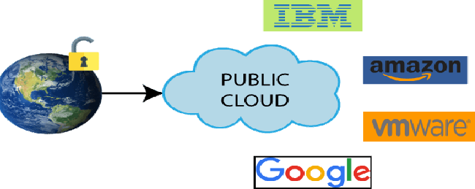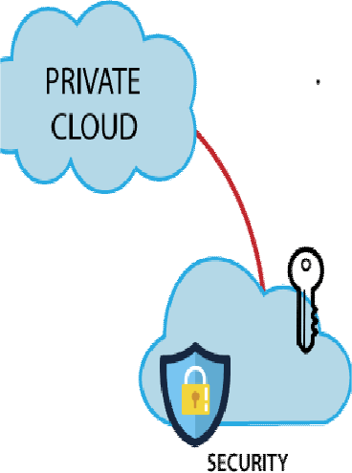

paper, family photos or the company payroll, cloud storage offers an easily accessiblebackup solution to keep data safe.

**Types of Cloud**

There are the following 4 types of cloud that you can deploy according to the organization's needs-

1. Public Cloud
2. Private Cloud
3. Hybrid Cloud
4. Community Cloud

# Public Cloud

* Public cloud is open to all to store and access information via the Internet using the pay-per-usage method. In public cloud, computing resources are managed and operated by the Cloud Service Provider (CSP).
* Example: Amazon elastic compute cloud (EC2), IBM SmartCloud Enterprise, Microsoft, Google App Engine, Windows Azure Services Platform.

Fig: Public cloud

# Advantages of Public Cloud

* Public cloud is owned at a lower cost than the private and hybrid cloud.
* Public cloud is maintained by the cloud service provider, so do not need to worry about themaintenance.
* Public cloud is easier to integrate. Hence it offers a better flexibility approach to consumers.
* Public cloud is location independent because its services are delivered through the internet.
* Public cloud is highly scalable as per the requirement of computing resources.
* It is accessible by the general public, so there is no limit to the number of users.

# Disadvantages of Public Cloud

* Public Cloud is less secure because resources are shared publicly.
* Performance depends upon the high-speed internet network link to the cloud provider.
* The Client has no control of data.

# Private Cloud

* Private cloud is also known as an internal cloud or corporate cloud. It is used by organizations to build and manage their own data centers internally or by the third party. It can be deployed using Open source tools such as Open stack and Eucalyptus.
* Based on the location and management, National Institute of Standards and Technology (NIST) divide private cloud into the following two parts-

1. On-premise private cloud
2. Outsourced private cloud

# Advantages of Private Cloud

* Private cloud provides a high level of security and privacy to the users.
* Private cloud offers better performance with improved speed and space capacity.
* It allows the IT team to quickly allocate and deliver on-demand IT resources.
* The organization has full control over the cloud because it is managed by the organization itself. So,there is no need for the organization to depend on anybody.
* It is suitable for organizations that require a separate cloud for their personal use and data securityis the first priority.

# Disadvantages of Private Cloud

* Skilled people are required to manage and operate cloud services.
* Private cloud is accessible within the organization, so the area of operations is limited.
* Private cloud is not suitable for organizations that have a high user base, and organizations that donot have the prebuilt infrastructure, sufficient manpower to maintain and manage the cloud.

# Hybrid Cloud

* Hybrid Cloud is a combination of the public cloud and the private cloud. we can say:
* *Hybrid Cloud = Public Cloud + Private Cloud*
* Hybrid cloud is partially secure because the services which are running on the public cloud can be accessed by anyone, while the services which are running on a private cloud can be accessed only by the organization's users.
* Example: Google Application Suite (Gmail, Google Apps, and Google Drive), Office 365 (MS Office on the Web and One Drive), Amazon Web Services.

Fig: Hybrid Cloud

# Advantages of Hybrid Cloud

* Hybrid cloud is suitable for organizations that require more security than the public cloud.
* Hybrid cloud helps you to deliver new products and services more quickly.
* Hybrid cloud provides an excellent way to reduce the risk.
* Hybrid cloud offers flexible resources because of the public cloud and secure resources because ofthe private cloud.

# Disadvantages of Hybrid Cloud

* In Hybrid Cloud, security feature is not as good as the private cloud.
* Managing a hybrid cloud is complex because it is difficult to manage more than one type of deployment model.
* In the hybrid cloud, the reliability of the services depends on cloud service providers.

# Community Cloud

* Community cloud allows systems and services to be accessible by a group of several organizations to share the information between the organization and a specific community. It is owned, managed, and operated by one or more organizations in the community, a third party, or a combination of them.
* Example: Health Care community cloud

Fig: Community cloud

# Advantages of Community Cloud

* Community cloud is cost-effective communities.

because the whole cloud is being shared by several organizations or

* Community cloud is suitable for organizations that want to have a collaborative cloud with moresecurity features than the public cloud.

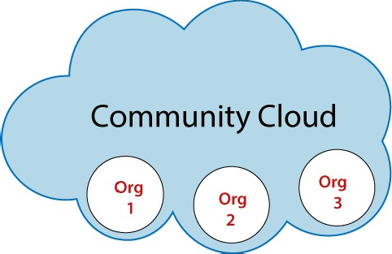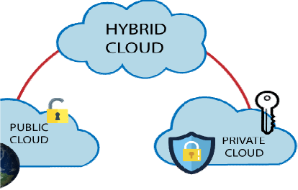

* It provides better security than the public cloud.
* It provides collaborative and distri utive environment.



* Community cloud allows us to share cloud resources, infrastructure, and other capabilities among various organizations.

# Disadvantages of Community Cloud

* Community cloud is not a good choice for every organization.
* Security features are not as good as the private cloud.
* It is not suitable if there is no collaboration.
* The fixed amount of data storage and bandwidth is shared among all community members.

# Difference between public cloud, private cloud, hybrid cloud, and community cloud –

|  |  |  |  |  |
| --- | --- | --- | --- | --- |
| Parameter | PublicCloud | Private Cloud | Hybrid Cloud | Community Cloud |
| Host | Service  provider | Enterprise (Third party) | Enterprise (Third party) | Community (Third party) |
| Users | Generalpublic | Selected users | Selected users | Community members |
| Access | Internet | Internet, VPN | Internet, VPN | Internet, VPN |
| Owner | Service  provider | Enterprise | Enterprise | Community |

**Goals & Challenges of cloud computing**



# Agility

The cloud works in a distributed computing environment. It shares resources among users and works very fast.

# High availability and reliability

The availability of servers is high and more reliable because the chances of infrastructure failure are minimum.

# High Scalability

Cloud offers "on-demand" provisioning of resources on a large scale, without having engineers for peak loads.

# Multi-Sharing

With the help of cloud computing, multiple users and applications can work more efficiently with cost reductions by sharing common infrastructure.

# Device and Location Independence

Cloud computing enables the users to access systems using a web browser regardless of their location or what device they use e.g. PC, mobile phone, etc. As infrastructure is off-site (typically provided by a third- party) and accessed via the Internet, users can connect from anywhere.

# Maintenance

Maintenance of cloud computing applications is easier, since they do not need to be installed on each user's

computer and can be accessed from different places. So, it reduces the cost also.

# Low Cost

By using cloud computing, the cost will be reduced because to take the services of cloud computing, IT company need not to set its own infrastructure and pay-as-per usage of resources.

# Services in the pay-per-use mode

Application Programming Interfaces (APIs) are provided to the users so that they can access services on the cloud by using these APIs and pay the charges as per the usage of services.

**Advantages of Cloud Computing**

As we all know that Cloud computing is trending technology. Almost every company switched theirservices on the cloud to rise the company growth.

Here, we are going to discuss some important advantages of Cloud Computing-

# Back-up and restore data

Once the data is stored in the cloud, it is easier to get back-up and restore that data using the cloud.



# Improved collaboration

Cloud applications improve collaboration by allowing groups of people to quickly and easily share information in the cloud via shared storage.

# Excellent accessibility

Cloud allows us to quickly and easily access store information anywhere, anytime in the whole world, using an internet connection. An internet cloud infrastructure increases organization productivity and efficiency by ensuring that our data is always accessible.

# Low maintenance cost

Cloud computing reduces both hardware and software maintenance costs for organizations.

# Mobility

Cloud computing allows us to easily access all cloud data via mobile.

# I Services in the pay-per-use model

Cloud computing offers Application Programming Interfaces (APIs) to the users for access services on the cloud and pays the charges as per the usage of service.

# Unlimited storage capacity

Cloud offers us a huge amount of storing capacity for storing our important data such as documents, images, audio, video, etc. in one place.

# Data security

Data security is one of the biggest advantages of cloud computing. Cloud offers many advanced features related to security and ensures that data is securely stored and handled.

**Disadvantages of Cloud Computing**



1. **Internet Connectivity**

As you know, in cloud computing, every data (image, audio, video, etc.) is stored on the cloud, and we access these data through the cloud by using the internet connection. If you do not have good internet connectivity, you cannot access these data. However, we have no any other way to access data from the cloud.

# Vendor lock-in

Vendor lock-in is the biggest disadvantage of cloud computing. Organizations may face problems when transferring their services from one vendor to another. As different vendors provide different platforms, that can cause difficulty moving from one cloud to another.

# Limited Control

As we know, cloud infrastructure is completely owned, managed, and monitored by the service provider, so the cloud users have less control over the function and execution of services within a cloud infrastructure.

# Security

Although cloud service providers implement the best security standards to store important information. But, before adopting cloud technology, you should be aware that you will be sending all your organization's sensitive information to a third party, i.e., a cloud computing service provider. While sending the data on the cloud, there may be a chance that your organization's information is hacked by Hackers.

**Leveraging Cloud Computing:**

* Cloud leverage is the ability to use cloud-based services to improve business performance while meeting or exceeding service-level agreements (SLAs).
* In order to understand cloud leverage, it’s essential to first understand what the cloud is. The cloud is a metaphor for the Internet. It is a way of describing how the Internet has changed the way we live and work.
* Cloud computing is the ability to access computing resources, such as applications and storage, over the Internet. This makes it possible for businesses to take advantage of cloud technologies without having to invest in their own infrastructure.
* When companies can easily and quickly get the resources they need, it’s called cloud leverage. Cloud leverage is the ability to use cloud-based services to improve business performance while meeting or exceeding service-level agreements (SLAs).
* There are many reasons why businesses should consider using cloud leverage, especially when it comes to their business intelligence (BI) tools. Let’s break down some of the ways that cloud leverage can lead the way in your business operation.

How cloud leverage can benefit your business intelligence Cloud leverage can help businesses in a number of ways. Here are just a few:

# Improved efficiency

* + By using the cloud, businesses can improve their efficiency by getting the resources they need when they need them. This eliminates the need to purchase and maintain hardware and software, which can be costly and time-



consuming.

* + The costs of maintaining and running a data center can be prohibitive for many businesses. The cloud allows businesses to outsource these costs and focus on their core competencies.
  + When companies don’t have to worry about the underlying infrastructure, they can concentrate on delivering value to their customers.

# Improved agility

* + The cloud also enables businesses to be more agile. With the cloud, businesses can quickly adapt to changes in the marketplace by deploying new applications and services.
  + This flexibility is essential in today’s fast-paced world. By using the cloud, businesses can stay competitive and quickly respond to changes in the market. This allows them to focus on their core competencies and not on infrastructure.

# Improved scalability

* + The cloud is also scalable, which means that businesses can adjust their resources as needed. This allows businesses to grow and change without having to invest in new hardware and software.
  + The cloud makes it possible for businesses to handle spikes in traffic or changes in demand without purchasing new equipment or making other costly investments.

# Improved security

* + Digital security is critical for businesses today. By using the cloud, businesses can improve their security by leveraging the service provider’s resources.
  + The cloud is also a more secure way to store and access data. Businesses can reduce their risk of data loss and theft by using the cloud.
  + The cloud provides a number of security features, including authentication, authorization, and encryption that businesses can take advantage of.



# Improved reliability

* + The cloud is also highly reliable. This means that businesses can rely on the cloud to deliver services according to their SLAs.
  + The cloud is a more reliable way to store and access data than traditional methods. Businesses can ensure that their data is safe and secure by using the cloud. The more reliable the cloud is, the more likely businesses are to use it.

# Why cloud leverage is so beneficial for BI

Now that we’ve looked at what cloud leverage is and how it can benefit your business let’s take a look at some practical applications as it relates to BI tools.

# Backup and disaster recovery

* + One of the most important applications of the cloud is backup and disaster recovery. By using the cloud, businesses can back up their data and ensure that it is safe and secure.
  + In the event of a disaster, businesses can quickly recover their data by accessing it from the cloud. This allows businesses to continue operating even in the event of a catastrophe.
  + For example, businesses can use the cloud to back up their data, applications, and operating systems. This ensures that they have a copy of their data in case of a disaster.

# Collaboration

* + The cloud is also an excellent way for businesses to collaborate. Businesses can share files and folders and work on projects together.
  + This allows businesses to work more efficiently and eliminates the need for email attachments.
  + Businesses can also use the cloud to host meetings and webinars. This allows employees to collaborate from anywhere in the world. The cloud is a great way to stay connected when you can’t be in the office.

# Hosting and streaming services

* + The cloud is also being used to host and stream services. Businesses can stream video and audio content to their customers by using the cloud. This allows businesses to provide a better customer experience and eliminates the need for dedicated streaming servers.
  + Businesses can also use the cloud to host their websites and applications. This eliminates the need for businesses to purchase and maintain their own servers.

# Marketing applications

* + The cloud is also being used for marketing applications. Businesses can collect and analyze data about their customers by using the cloud.
  + This allows businesses to create targeted marketing campaigns and improve their ROI.
  + Businesses can also use the cloud to store and manage their customer data. This allows businesses to keep track of their customers’ purchases and preferences.



# Business process automation

* + The cloud is also being used to automate business processes.
  + Businesses can streamline their operations and improve their efficiency by using the cloud.
  + Cloud-based applications allow businesses to automate tasks such as payroll processing, invoicing, and order tracking. This allows businesses to save time and money.
  + Businesses can also use the cloud to manage their finances. This allows companies to keep track of their expenses and revenue.

# ecommerce

* + The cloud is also being used for e-commerce. By using the cloud, businesses can process payments and accept orders online.
  + This allows businesses to sell products and services online.
  + Businesses can also use the cloud to store their inventory and track their sales. This allows businesses to make better decisions about their product lines.

# How to get started with cloud leverage

If you’re interested in using the cloud to benefit your business, it’s important to start small and scale as you go. Here are a few tips to help you get started:

# Evaluate your needs

Before you can start using the cloud, you need to evaluate your needs. What applications and services do you want to move to the cloud? What are your backup and disaster recovery plans?

# Choose the right provider

Not all cloud providers are created equal. It’s important to choose a provider that is reliable and has a good reputation. Make sure to read reviews and compare pricing.



# Start small

It’s important to start small when you’re first getting started with the cloud. Try moving a few applications and services to the cloud and see how it works for you.

# Scale as you go

As your business grows, you may need to add more services and applications to the cloud. Scale your cloud deployment as needed. Don’t try to do everything at once.

# Train your teams to adapt

Your employees will need to be trained on how to use the cloud. Make sure they understand the benefits of using the cloud and how to use it safely and securely.

**What Is TCO In Cloud Computing?**

* + The total cost of ownership in cloud computing refers to the total cost of adopting, operating, and provisioning cloud infrastructure.
  + Organizations often find it necessary to perform a cloud TCO analysis when they are considering moving to the cloud because it allows them to weigh the cost of cloud adoption against the cost of running their current on- premise systems.
  + Since TCO is typically used to understand the lifetime cost and value of static or contained resources, however, estimating the TCO of cloud infrastructure — an inherently dynamic ecosystem — can be challenging.
  + When businesses calculate cloud TCO, they often make an apples-to-apples comparison of the costs of running an on-premise system versus the cost of running the same system in the cloud.
  + That is, comparing the initial purchase price of hardware and software in an on-premise environment to the monthly subscription cost of cloud computing.
  + For example, a common starting point might be: “How much will it cost to run my on-premises system in the cloud?” or “If I have 3,000 traditional servers in my datacenter, what is the rack-rate for 3,000 compute instances of similar CPU, memory, and networking capacity in the cloud over *x* period?”
  + While this is a good place to start, you may not get the full picture. This is because a head-to-head comparison does not capture hidden costs or intangible costs of not switching to the cloud (i.e. the benefits of a cloud solution), such as faster time to market, increased productivity, and elasticity of demand.
  + To accurately calculate cloud TCO, you must capture not only the purchase price of on-premises vs. cloud solutions but also the intangible costs associated with either solution.

The best approach and practices when evaluating the total cost of ownership for cloud computing.

# Steps For Calculating Cloud TCO

**Step 1: Calculate your current IT infrastructure costs**

Understanding the actual cost of your current IT solution is the first step. This means calculating the direct and indirect costs of running and maintaining your current system as well as estimating your current workloads, including servers,



databases, storage, and network bandwidth.

# Consider the following cost areas:

* + Hardware and infrastructure—Identify the cost of the hardware that powers your on-premise application. These include physical servers, supplies, spare parts, etc.
  + Datacenter—How much does it cost to power your data center? How much does it cost to meet your current cooling, power, and space requirements?
  + Software—Calculate your current software usage, including the number of licenses and cost of these licenses.
  + Personnel—Identify all the personnel involved in system, network, and database administration and how much it costs to payroll them.
  + Disaster recovery—If you have a disaster recovery system in place, how much does it cost to maintain and manage that site?
  + Maintenance—Calculate the cost of servicing, operating, and maintaining the system, including the cost of both in- house and outsourced maintenance.
  + Upgrades—How much will it cost to upgrade the system if the need arises? Would you need to overhaul the system completely?
  + Security—Estimate the total cost of securing your current system, from the cost of physical security to firewalls and security experts.
  + Hidden costs—How much does downtime cost you? Review log files to determine server downtime frequency, hours lost, and the cost implication of those hours.

# Step 2: Estimate the cost of a cloud solution

* + Next, calculate the cost of operating your applications in the cloud. Keep in mind that many of the cost areas considered for on-premises infrastructure will not apply in the cloud because they will be offloaded to the cloud service provider.



* + However, it’s important to note that a cloud solution is not inherently cheaper than on-premises infrastructure.
  + When businesses switch to the cloud, they often assume that their cloud bill will be automatically cheaper.
  + But the on-demand nature of cloud services means your cloud bill could quickly spiral out of control as developers deploy instances and move at the speed of the cloud.
  + Understanding the major cost areas in the cloud is key to optimizing your cloud cost and ensuring a lower TCO.
  + Two of the major cost areas to consider for the cloud are **migration costs** and the monthly cost of your selected cloud services.

# Migration costs

Moving your applications and data to the cloud is a key step when switching to the cloud. Your current applications may require modification to function properly in the cloud. Gartner identifies the five ways to move applications into the cloud, namely:

* + Rehosting applications without making any changes to their architecture
  + Refactoring or running applications on a cloud provider's infrastructure
  + Revising the application, i.e. modifying or extending the existing code base
  + Rebuilding or rearchitecting the entire application for the cloud
  + Replacing the application with commercial software delivered as a service

Each application migration method has its cost implications and you need to determine the costs associated with the method you choose.

In addition to application migration costs, estimate data transfer charges that will accrue when moving your application.

# Monthly cloud cost

* + Your monthly cloud cost will depend on your workloads, and the specific cloud services consumed and method of purchase.
  + The goal here is to estimate your potential monthly cloud bill based on your current workloads.
  + Since this calculation differs considerably for each organization, major cloud platforms provide pricing calculators that make it easier to estimate your monthly cloud bill.
  + The AWS pricing calculator, for example, allows you to estimate your infrastructure cost based on the retinue of AWS products and services selected.

Two of the major factors that will affect the size of your cloud bill are:

1. **Type of cloud services consumed:** Commodity services, such as storage or raw compute power, are relatively less expensive compared to more specialized services, such as machine learning.

Amazon, for instance, offers Recognition which does image and video analysis, and Polly, which is a text-to-speech service. These services have higher workload costs than storage. The total cost will depend on the types of services your business needs.

1. **Cloud consumption model:** The on-demand model, where resources are deployed as needed, is the most popular cloud usage model. However, it is also the most expensive cloud consumption model. The other way to consume cloud



services is to use a savings plan or prepaid option (reserved instances). You could also opt for a hybrid model. Your cloud costs will differ depending on the consumption model your business adopts.

# Consultation and training costs

If your team lacks the expertise required for the migration process, factor in the cost of hiring consultants for training.

# Step 3: Consider the intangible benefits of the cloud

Beyond comparing the monetary implications of on-premise versus cloud solutions, there are opportunity costs associated with *not* switching to the cloud. You need to quantify what this means for your business.

* + **Innovation**—the cloud offers hundreds of services you can access on demand. By continuing with an on-premises system, you sacrifice the ability of developers to move fast and respond quickly to market changes.
  + **Elasticity**—handling demand in an on-premise environment is always a challenge. The solution is usually to maintain redundant infrastructure in anticipation of peak loads. In the cloud, however, you could easily deploy instances to take care of the additional peak without any downtime.

When the peak is over, you go back to operating at your normal capacity at no additional cost. While you may incur a larger monthly cloud bill at peak, you will experience no downtime nor would you need to maintain redundant infrastructure when the surge is over.